SGMW
Functional Specification
功能规范

会签：

编制： 校对：
审核： 批准：

目录
1 文档范围及控制方法 4
1.1 版本历史 4
1.2 缩写 4
1.3 目的 6
1.4 适用范围 6
1.5 文档批准权力 6
1.6 文档变更控制流程 6
1.7 规范性引用文件 6
1.8 命名办法 6
1.8.1 日期表示 6
1.8.2 文件版本编号 7
1.8.3 文件命名 7
2 功能描述 错误!未定义书签。
3 系统架构 错误!未定义书签。
3.1 功能架构 错误!未定义书签。
3.1.1 与子系统自身控制功能边界区分 错误!未定义书签。
3.2 功能状态机 错误!未定义书签。
3.3 功能接口描述 错误!未定义书签。
3.3.1 总线信号 10
4 执行器需求 错误!未定义书签。
4.1 执行器安全需求 错误!未定义书签。
5 功能逻辑策略 错误!未定义书签。
5.1 功能逻辑策略概览 错误!未定义书签。
5.1.1 功能激活和退出策略 15
5.1.2 控制逻辑 错误!未定义书签。
5.1.3 功能降级策略 23
5.1.4 技术指标 23
5.1.5 验收准则 23
6 显示策略(HMI) 23
7 法律法规需求 23

文档范围及控制方法

版本历史

版本 | 变更内容 | 变更原因 | 变更人 | 日期
v1.0 | 优化初始版本 | 模板更改 | 蒙毓森 | 2025/08/08
V2.0 | Comfortable Stop舒适制动功能规范初版 |  | 杨震 | 2025/10/20

缩写
控制器模块缩写
系列 | 缩写 | 英文描述 | 中文描述
A | ABS | Anti-locked Braking System | 防抱死制动系统
 | ACC | Adaptive Cruise Control | 自适应巡航控制
 | ACU | Automatic Clutch Unit | 自动离合器单元
 | AEB | Automatic Emergency Braking | 自动紧急制动
 | AR-HUD | Augmented Reality Head Up Display | 增强现实抬头显示
 | AVM | Around View Monitor | 全景影像系统
B | BCM | Body Control Module | 车身控制模块
 | BMS | Battery Manage System | 动力电池管理系统
C | CDU | Charging Distribut Unit | 充电模块单元
 | CMS | Mu-Split Compensation | 分离路面补偿功能
 | CDDU | Charging and Discharge Unit | 充放电模块单元
 | CS | Combination Switch | 组合开关
D | DCDC | DC/DC Converter | 直流直流转换器
E | ECM | Engine Control Module | 发动机控制模块
 | EBS | E_Booster | 电子制动助力器
 | EHBI | Electronic Hydraulic Brake integrate | 集成式电子液压制动系统
 | EPS | Electronic Power Steering | 电动转向系统
 | EPB | Electronic Parking Brke | 电子驻车制动系统
 | ESC | Electronic Stability Control | 电子稳定系统
 | EVCC | Electric Vehicle Communication Controller | 充电通讯控制模块
 | EXV | Electronic EXpansion Valve | 电子膨胀阀
 | EVP | Electronic Vacuum Pump | 电子真空泵
G | GW | Gateway | 网关
H | HCU | Hybrid Control Unit | 混合动力控制器
I | IBC | Intelligent Body Controller | 智能车身控模块
 | IBS | Intelligent Battery Sensor | 智能蓄电池传感器
 | IC | Instrument Cluster | 组合仪表
 | ICE | In Car Entertainment | 车载娱乐系统
 | IDU | Intelligent Driving Unit | 智能驾驶控制器
 | IMMO | Immobilization | 防盗线圈
L | LCA | Lane Challenge Assist | 变道辅助系统
 | LDW | Lane Departure Warning | 车道偏离报警系统
 | LSDC | Low Speed Driving Characteristic | 低速驾驶特性
M | MCU | Motor Control Unit | 驱动电机控制器
 | MSB | Motor Seat Belt | 电动马达安全带
O | OBC | On Bord Of Charger | 车载充电器
 | OBD | On-Board Diagnostics | 车载诊断接口
 | OCC | OFF-board Conductive Charger | 非车载传导式充电机
P | PCU | Powertrain Control Unit | 动力系统控制模块总成
 | PDM | Passenger Door Module | 副驾车窗电机总成
 | PDSM | Passenger Door Switch Main | 副驾开关模块
 | PEPS | Passive Entry Passive Start | 无钥匙进入及一键启动系统
 | PLG | Power Lift Gate | 电动尾门控制模块
R | RRS | Reversing Radar SensorModule | 倒车雷达传感器控制模块
 | RSM | Radar Sensor Module | 雷达传感器模块
S | SAS | Steering Angle Sensor | 转角传感器
 | SCU | Shift Control Unit | 换档器模块
 | SRR-FR | SRR Front Right | 毫米波雷达-右前
 | SRR-FL | SRR Front Left | 毫米波雷达-左前
 | SRR-RR | SRR Rear Right | 毫米波雷达-右后
 | SRR-RL | SRR Rear Left | 毫米波雷达-左后
T | TBOX | Telematics BOX | 车载无线终端
 | TCM | Transmission Control Module | 变速箱控制模块
 | TICE | T-In Car Entertainment | 网联导航通信系统
 | TEM | Telematics Module | 远程信息处理模块
 | TPMS | Tire Pressure Monitoring System | 胎压监测系统
 | TOBD | Test On-Board Diagnostics | 测试诊断口
U | URC | Ultrasonic Radar Controller | 超声波雷达控制器
V | VCU | Vehicle Control Unit | 整车控制器
 | VPM | Visual Perception Module | 视觉模块
W | WMM | Wiper Motor Module | 雨刮电机模块
Z | ZCU-L | Left Zone Control Unit | 左区域控制器
 | ZCU-R | Right Zone Control Unit | 右区域控制器

目的
本功能设计规范用于指导上汽通用五菱汽车股份有限公司与采埃孚汽车科技（上海）有限公司，开展关于智驱一体化底盘协同控制项目中Comfortable Stop 舒适制动功能的开发。

适用范围
本文档适用于 SGMW智驱一体化底盘协同控制项目功能开发阶段。

文档批准权力
本文档为功能实现文档，需经过 SGMW智驱一体化底盘协同控制项目组签字确认。

文档变更控制流程
任何文档内容更新均须经过SGMW智驱一体化底盘协同控制项目组评审及签署完成。
在未经SGMW智驱一体化底盘协同控制项目组达成共同意见下，该文档将不能被单方面进行修改。

规范性引用文件
下列文件中的条款通过本标准的引用成为本标准的条款。凡是注日期的引用文件，其随后的修改单（不包括勘误的内容）或修订版均不适用于本标准。凡是不注日期的引用文件，其最新版本适用于本标准。
标号 | 标题 | 版本/修改日期
Ref.1

命名办法

日期表示
格式：yyyymmdd
- yyyy：用四位数字表示公元年份，如2013表示公元 2013年；
- mm：用两位数字表示月份，不足两位时，第一位用零补齐，如03表示3月；
- dd：用两位数字表示日期，不足两位时，第一位用零补齐，如15表示第15号。
例如：
20101027 表示（2010 年 10月 27日）

文件版本编号
下面是对文件版本进行编号要遵守的标准：
- 起草版本的编号为0.1，0.2，0.3，…，0.10；
- 一旦文件版本得以确认后，版本编号应该始自1.0；
- 版本编号不断变化为：1.0，1.1，1.2，…，1.10；
- 项目可以根据需要将版本编号晋升为2.0，2.1，2.2等。

文件命名
格式：SGMW_VMC_FS_Dn-Sn-Fn_XXX_Vnn_yyyymmdd
- SGMW_VMC：项目简称；
- FS：Functional specification ,功能需求描述；
- Dn-Sn-Fn：功能 ID；
- XXX：功能名称；
- Vnn：文件版本；
- yyyymmdd：文件形成日期。

Function description
Comfortable Stop (CST) is an optional comfort feature designed to address deceleration fluctuations occurring before vehicle braking during non-emergency deceleration scenarios. It reduces vehicle braking pitch by utilizing braking (only electric braking options) and suspension control (damping, stiffness, and height) to achieve a comfortable braking experience.。
CST functionality activates only when the vehicle decelerates to a stop in non-emergency situations, providing the driver with a smooth sensation.，
- When vehicle speed falls below a threshold value and driver's braking request exceeds a specified threshold, the CST function activates (“CST_Status” = Active). Deceleration is then controlled via CST(only electric braking). VMC CST function shall be responsible for ensuring a smooth transition.
- To stop the vehicle smoothly CST will use RPM control when vehicle is coming to Standstill status. When the vehicle stops (standstill checked), the CST function will exit (“CST_Status” = Standby). The braking request from the VMC (hydraulic braking and electric braking are optional) must ramp out. The braking system needs to be boosted to keep vehicle in position. Brake actuator shall be responsible for ensuring a smooth transition
- When the driver brakes urgently and execeeds a deceleration limit, the CST function needs to be deactivated (“CST_Status” = Standby). The braking system needs to be boosted to fullfill the driver's request. Brake actuator shall be responsible for ensuring a smooth transition.

- When the driver releases the brake pedal (master cylinder pressure falls below xx bar), the CST function needs to exit (“CST_Status” = Standby).

- When the vehicle is detected to be operating on road with bad condition (snow/sand…, which can be detected by SGMW AI road surface detection feature) or driving on a slope (slope ≥15% TBD), the CST function needs to exit (“CST_Status” = Standby). The braking system needs to be boosted to respond the driver's request. Brake actuator shall be responsible for ensuring a smooth transition.

- When the vehicle stability control function is activated
  - Brake： Stability control functions such as ABS, EBD, TCS, YSC, and DTC activated
  - VMC： TankTurn, CompasTurn, Pre-stab, CMS TBH all stability features activated
CST functionality needs to exit (“CST_Status” = Standby). The braking system needs to be boosted to respond the driver's request. Brake actuator shall be responsible for ensuring a smooth transition.
- When ADAS function is activated, the CST function must be deactivated (“CST_Status” = Standby). The braking system needs to be boosted to respond the ADAS's request. Brake actuator shall be responsible for ensuring a smooth transition.
- If the driver manually presses the switch (HMI sends CSTSwt 0x0: Not Pressed, 0x1: Pressed, 5 frames valid?), the Host ECU is responsible for detecting signal validity (valid for over 5 frames). Subsequently, the Host ECU sends a switch toggle request (rising edge/falling edge) to the VMC via the RTE signal. The VMC must determine the Swith_On conditions (fault, switch signal Valid, etc.) and switch change requests (rising/falling edge), then transition to the requested state based on the CST's own status (e.g., off->standby or standby->off). The HMI must switch the Light status of the CST function based on the CST status signal (“CST_Status” = Off/Non-off) fed back by VMC.
- After a normal power-down, the CST switch status must be retained in memory. The VMC must send the memory CST status to the Host ECU via RTE. The Host ECU must store this switch status signal in NVRAM. Upon subsequent power-up, the stored status must be sent to the VMC. The HMI must display the current CST function switch status on the HMI based on the feedback from the CST.

System Architecture

Functional Architecture

Distinguishing Boundaries from the Subsystem's Own Control Functions
The CST function of the VMC primarily operates through braking (only electric braking) and suspension control.

- VCU（regen optional）：
When CST activated, VMC sends Regen requests (regen request flag& target value) to VCU. If the VCU receives a higher-priority request from the braking system (e.g., certain stability functions or DTCs), it overrides the VMC. VMC's CST function(“CST_Status” = Standby) will exit at the same time.
When CST activated, VMC sends max speed front/rear to VCU, VCU needs to limit current Motor Speeds under this limitation. For 4x Motors Variants this value shall be same.
When CST function exits for any reason (“CST_Status” = Standby/Off/Failure), VCU shall take over the coasting control and ramp to target coasting torque request. VCU shall not follow RPM limitation any more.
When CST function actives, VMC will take over the regen control and ramping to target regen torque from actual coasting torque value.
  - Who is responsible for the handover, and who is responsible for ensuring smoothness

- Brake actuator（no control of Brake, but need get signals from brake for ensuring smooth transition）：
  - After VMC CST activation, the brake actuator must ramp down the brake request (hydraulic brake) to zero. The VMC CST function will increase regen torque based on actual residual brake torque and ensuring a smooth transition.
  - When the VMC CST function exits for any reason (“CST_Status” = Standby/Off/Failure), the VMC CST function must ramp the braking request (only electric brake) to standard value (0 or standard coasting value). The brake actuator must ensure to response driver request at the time of VMC exit to prevent vehicle overshoot. Brake actuator shall be responsible for ensuring a smooth transition.
  - Who is responsible for the handover, and who is responsible for ensuring smoothness

- Active Suspension： VMC controls the damping and stiffness of the four-wheel lateral active suspension. It coordinates with braking control (electric braking only) to reduce the impact of braking pitch. During CST activation, VMC holds the highest control priority of Active Suspension.
- CDC：
VMC controls the damping and stiffness of the four-wheel lateral CDC. It coordinates with braking (electric braking only) control to reduce the impact of braking pitch. CDC control is a range control (Min+Max)
- Air Spring：
VMC controls the stiffness of the air spring (single-wheel independent control is not currently implemented). It coordinates with braking control (electric braking only) to reduce the impact of braking pitch. During CST activation, VMC holds the highest control priority.

Functional State Machine
Reference 5.1.1 Function Activation and Exit Logic

Interface Description

总线信号
- 如下是CST 2.0功能关键的输入输出接口，如需完整的信号列表，请参考最新的 CAN matrix 信号矩阵表。
TX | RX | ID | Signal name | Singal description | 起始字节 | 起始位 | 信号长度
HMI | VMCU |  | CSTSwt | CST switch |  |  |  | 0x0: Not press  0x1: Press
VMCU | HMI |  | VMCSoftStopFlg | CST feedback status |  |  |  | 0x0: CST is Off  0x1: CST is Standby  0x2: CST is Active  0x3: CST is Failure
VCU | VMCU |  | DiffLockCtrlSts | 差速锁控制模式 |  |  |  | $0=Open（断开）  $1=Hold（闭合）  $2=Fault（故障）
制动 | VMCU | 0X17D | VehSpdAvgDrvn_ABS | Vehicle speed
SBW | VMCU |  | StrWhAng | Steering wheel angle
SDM | VMCU |  | VSELongAcc_1 | Long acceleration
SDM | VMCU |  | VSELongAccV_1 | Long acceleration Valid |  |  |  | $0=Valid（有效）  $1=Invalid（无效）
IMU | VMCU |  | VSELatAcc_1 | Lateral acceleration
IMU | VMCU |  | VSELatAccV_1 | Lateral acceleration valid |  |  |  | $0=Valid（有效）  $1=Invalid（无效）
VCU | VMCU |  | AccActPos_FD | Accel pedal position
VCU | VMCU |  | AccActPosV_FD | Accel pedal position Valid |  |  |  | $0=Valid（有效）  $1=Invalid（无效）
制动 | VMCU |  | LtFntWhlGrndVlcty  RtFntWhlGrndVlcty  LtRrWhlGrndVlcty  RtRrWhlGrndVlcty | Wheel speed
制动 | VMCU |  | WhlActBrkTq_FL/FR/RL/RR | Wheel actual brake torque
制动 | VMCU |  | OverlayBrkActrRqstSts | Overlay Brake Actuator Feedback Status |  |  |  | $0=Not_Controllable  $1=Ready_for_Control  $2=Controlled  $3=Override  $4=Error
VMCU | 制动 |  | BrkDltTrqCtrlAtvRqstFlg | Brake Delta Torque Control Activation Request Flag |  |  |  | $0=NoRequest  $1=Requst
VMCU | 制动 |  | TarBrkTqFL  TarBrkTqFR  TarBrkTqRL  TarBrkTqRR | Target Overlay Brake Torque FL/FR/RL/RR
VCU | VMCU |  | VehActGrStsESC_FD | The current gear status of the vehicle |  |  |  | $0=Initialize（初始化）  $1=Unused and Reserved（预留）  $2=Unused and Reserved（预留）  $3=Unused and Reserved（预留）  $4=Unused and Reserved（预留）  $5=Unused and Reserved（预留）  $6=error（ 故障）  $7=Unused and Reserved（预留）  $8=Unused and Reserved（预留）  $a=Park gear（P档）  $b=Sport Gear（S档）  $c=Drive Gear（D档）  $d=Neutral Gear（空档）  $e=Reverse Gear（倒档）  $f=Unused and Reserved（预留）
制动 | VMCU |  | ABSAtv_FD | ABS working status |  |  |  | $0=False（不工作）  $1=True（工作）
制动 | VMCU |  | VSEAtv_FD | ESP working status |  |  |  | $0=False（不工作）  $1=True（工作）
制动 | VMCU |  | VSEArmAtv | ARM working status |  |  |  | $0=False（不工作）  $1=True（工作）
制动 | VMCU |  | TCSysAtv_FD | TC working status |  |  |  | $0=False（不工作）  $1=True（工作）
制动 | VMCU |  |  | DTC working status |  |  |  | $0=False（不工作）  $1=True（工作）
VCU | VMCU |  |  | Road condition AI detection
VCU | VMCU |  | VCUADASactvSts | ADAS active feature status |  |  |  | $0= Not Active  $1= ACC  $2= APA  $3= AEB  $4= AES
VCU | VMCU |  | PrDrvMtrTorqMinLitVal_FD | For 2Motor: min Torque capa (regen) Front axle  For 4Motor: min torque(regen) FL
VCU | VMCU |  | MCU2MtrTorqMinLitVal_FD | For 2Motor: min Torque capa (regen) Rear axle  For 4Motor: min torque(regen) FR
VCU | VMCU |  | MCU3MtrTorqMinLitVal_FD | Only For 4Motor: min torque capa(regen) RL
VCU | VMCU |  | MCU4MtrTorqMinLitVal_FD | Only For 4Motor: min torque capa(regen) RR
VCU | VMCU |  | DrvActrStsFb | Drive Control Feedback Status |  |  |  | $0 = Not_Controllable  $1 = Ready_for_Control  $2 = Controlled  #3 = Error  $4 = Override
VMCU | VCU |  | TarRegTrqFront/ TarRegTrqRear | VMC regen torque request (front/rear)
VMCU | VCU |  | TotTarRegTrqCotrlRqst | VMC regen torque request flag
VMCU | VCU |  | RpmLimFrnt | Max Speed front
VMCU | VCU |  | RpmLimRe | Max Speed rear
VMCU | CDC |  | CdcActvRqst | CDC request flag |  |  |  | $0=No Request（无请求）  $1=Request（请求）
VMCU | CDC |  | CdcCurrentMax/MinRqst_FL  CdcCurrentMax/MinRqst_FR CdcCurrentMax/MinRqst_RL  CdcCurrentMax/MinRqst_RR | CDC Max/Min current request FL/FR/RL/RR
CDC | VMCU |  | CdcActrStsFb | CDC feedback status |  |  |  | $0=Not_Controllable  $1=Ready_for_Control  $2=Controlled  $3=Error  $4=Reserved  $5=Reserved  $6=Reserved  $7=Reserved
CDC | VMCU |  | SUCUVlvActuCrntFL  SUCUVlvActuCrntFR  SUCUVlvActuCrntRL  SUCUVlvActuCrntRR | SUCU左前电磁阀实际电流百分比  SUCU右前电磁阀实际电流百分比  SUCU左后电磁阀实际电流百分比  SUCU右后电磁阀实际电流百分比
CDC | VMCU |  | CdcBaseCurrent_FL  CdcBaseCurrent_FR  CdcBaseCurrent_RL  CdcBaseCurrent_RR | 左前CDC基础电流百分比  右前CDC基础电流百分比  左后CDC基础电流百分比  右后CDC基础电流百分比
VMCU | ActvSusp |  | ActvSuspActvRqst | 主动悬架激活请求 |  |  |  | $0=No Request（无请求）  $1=Mode Roll Distribution  $2=Mode Damper Force  $3=Reserved  $4=Reserved  $5=Reserved  $6=Reserved  $7=Reserved
VMCU | ActvSusp |  | AntiRollTqDistbn | 前后轴防侧倾总扭矩目标分配
VMCU | ActvSusp |  | ActvSuspTarForce_FL | 左前轮目标主动阻尼力
VMCU | ActvSusp |  | ActvSuspTarForce_FR | 右前轮目标主动阻尼力
VMCU | ActvSusp |  | ActvSuspTarForce_RL | 左后轮目标主动阻尼力
VMCU | ActvSusp |  | ActvSuspTarForce_RR | 右后轮目标主动阻尼力
ActvSusp | VMCU |  | ActSuspActrSts | 主动悬架执行器状态 |  |  |  | $0=Not_Controllable  $1=Ready_for_Control  $2=Mode_RollDistribution  $3=Control_Mode_Damper_Force  $4=Error  $5=Reserved  $6=Reserved  $7=Reserved
ActvSusp | VMCU |  | ActSuspCtrlOrigTargtDampForce_FL | 左前轮减震器目标主动力
ActvSusp | VMCU |  | ActSuspCtrlOrigTargtDampForce_FR | 右前轮减震器目标主动力
ActvSusp | VMCU |  | ActSuspCtrlOrigTargtDampForce_RL | 左后轮减震器目标主动力
ActvSusp | VMCU |  | ActSuspCtrlOrigTargtDampForce_RR | 右后轮减震器目标主动力
ActvSusp | VMCU |  | ActSuspActulDampForce_FL | 左前减振器实际减振力
ActvSusp | VMCU |  | ActSuspActulDampForce_FR | 右前减振器实际减振力
ActvSusp | VMCU |  | ActSuspActulDampForce_RL | 左后减振器实际减振力
ActvSusp | VMCU |  | ActSuspActulDampForce_RR | 右后减振器实际减振力
VMCU | AirSpring |  | AirSuspActvRqst | 空簧执行请求 |  |  |  | $0=No Request（无请求）  $1=Request（请求）
VMCU | AirSpring |  | TarStfnLvlFrntLe | 左前空簧目标刚度等级 |  |  |  | $0=Default  $1=Level 1  $2=Level 2  $3=Reserve
VMCU | AirSpring |  | TarStfnLvlFrntRi | 右前空簧目标刚度等级 |  |  |  | $0=Default  $1=Level 1  $2=Level 2  $3=Reserve
VMCU | AirSpring |  | TarStfnLvlReLe | 左后空簧目标刚度等级 |  |  |  | $0=Default  $1=Level 1  $2=Level 2  $3=Reserve
VMCU | AirSpring |  | TarStfnLvlReRi | 右后空簧目标刚度等级 |  |  |  | $0=Default  $1=Level 1  $2=Level 2  $3=Reserve
AirSpring | VMCU |  | AirSpringActrStsFb | 空气弹簧执行器状态反馈 |  |  |  | $0=Not_Controllable  $1=Ready_for_Control  $2=Controlled  $3=Error  $4=Reserved  $7=Reserved
AirSpring | VMCU |  | ECASLtFntRealH | 空簧系统左前实际高度
AirSpring | VMCU |  | ECASRtFntRealH | 空簧系统右前实际高度
AirSpring | VMCU |  | ECASLtRrtRealH | 空簧系统左后实际高度
AirSpring | VMCU |  | ECASLtRrRealH | 空簧系统右后实际高度
AirSpring | VMCU |  | SuspStiffFrntLe | 左前空簧当前刚度等级 |  |  |  | $0=Default  $1=Level 1  $2=Level 2  $3=Reserve
AirSpring | VMCU |  | SuspStiffFrntRi | 右前空簧当前刚度等级 |  |  |  | $0=Default  $1=Level 1  $2=Level 2  $3=Reserve
AirSpring | VMCU |  | SuspStiffReLe | 左后空簧当前刚度等级 |  |  |  | $0=Default  $1=Level 1  $2=Level 2  $3=Reserve
AirSpring | VMCU |  | SuspStiffReRi | 右后空簧当前刚度等级 |  |  |  | $0=Default  $1=Level 1  $2=Level 2  $3=Reserve

Actuator Requirements
This function requires control of the rear-end actuator, brake actuator, and others. At least one actuator must be available.

Actuator Safety Requirements
相关执行器安全要求，请参考safety 相关文档。

Functional Logic Strategy

General View
CST Function Logic: Achieves smooth deceleration solely through braking (hydraulic/electrical braking optional), while suspension actuators dynamically adjust suspension stiffness to further optimize pitch control.

State Machine of CST
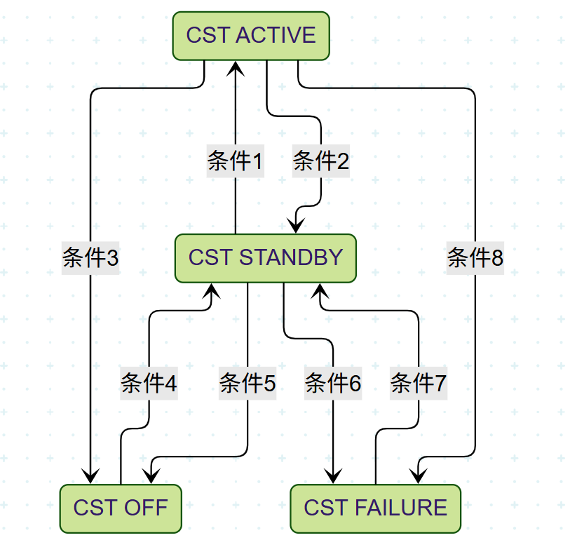
条件1：When all of the following conditions are met, CST Standby switches to Active.
- CST switch on
- No degradation
- Signals valid
- ABS, TCS,YSC …not activated
- Drive mode( non-sport)
- Road surface conditions are good (determined based on road surface recognition AI)
- Motor regeneration torque unrestricted (high SOC/low temperature/motor torque limit) ）
- ADAS not activated。
- Brake pedal pressure exceeds threshold (accounting for hill-hold pressure)）
- Brake pedal rate below threshold (non-emergency braking)）
- Speed range （TBD< speed< TBD）
- Deceleration range
- Slope less than threshold
- Forward driving
- Lateral acceleration < xx
- Steering angle less than threshold
条件2： If any of the following conditions are met, CST Active switches to Standby.
- AEB,ABS, TCS,YSC e.g. activated
- Driver brake pedal position below threshold (Driver releases brake pedal)）
- Bad road
- Motor regeneration torque limited (high SOC/low temperature/motor torque limit)）
- Out of speed range。
- Brake pedal rate too high
- ADAS activated.
- Drive mode( sport)

条件3： If any of the following conditions are met, CST Active switches to off.
- Switch off
- Switch signal invalid

条件4： When all of the following conditions are met simultaneously, CST off switches to Standby.
- Switch on
- Switch signal valid
- Key signals valid （speed e.g.）
- No degradation
条件5： If any of the following conditions are met, CST Standby switches to off.
- Switch off
条件6： If any of the following conditions are met, CST Standby switches to failure.
- Fault Degradation (including electric braking capability failure)）
- Key signals invalid
条件7： When all of the following conditions are met simultaneously, the primary system fails over to the standby system.
- Fault recover
- Signals recover
- Switch on
条件8： If any of the following conditions are met, CST active switches to failure.
- Fault Degradation (including electric braking capability failure)
- Key signals invalid

Control Logic
Core Control Algorithm: By adjusting the braking torque (hydraulic/electrical) on the front and rear axles through feedforward control (based on deceleration, pitch angle, and pitch angle derivative) and feedback control (with pitch angle as the control target), the pitch angle is reduced to achieve comfortable braking.
The suspension also targets pitch angle as a control objective, further optimizing vehicle nose-dive by adjusting suspension stiffness.

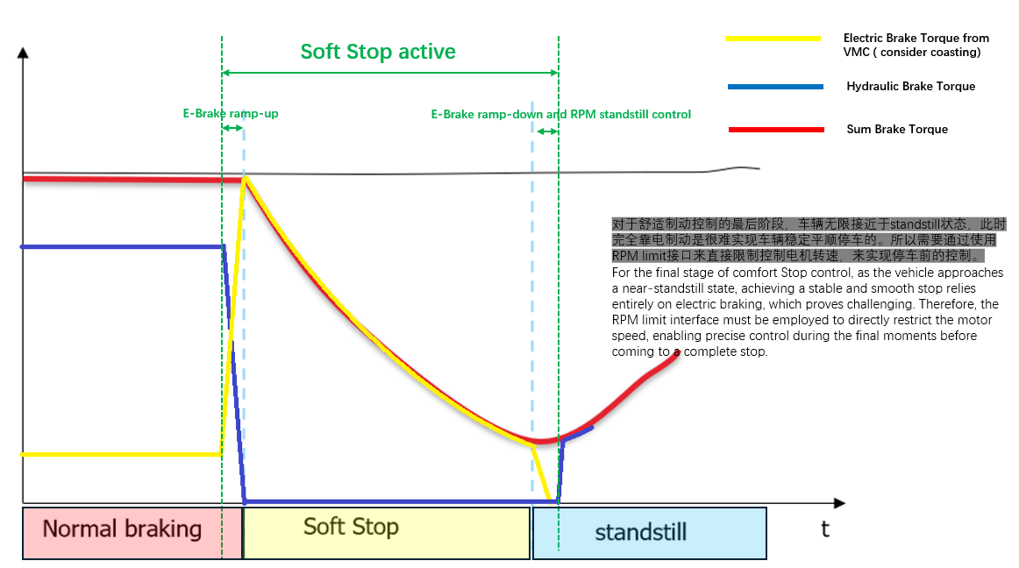
When the CST control function is active, it utilizes all available actuators within the following ranges: including:：

Drive Actuator (Regen torque control/ distribution）
Send to VCU
All-Wheel Drive (2xMotors): The CST function requests electric braking torque for the front and rear axles from the VCU.
      - 电制动扭矩激活请求TotTarRegTrqCotrlRqst =0x01（Request请求）
      - TarRegTrqFront/ TarRegTrqRear，only when TotTarRegTrqCotrlRqst=0x01，these regen torque request shall be implemented。
      - RpmLimFrnt/ RpmLimRe ： only when VMCSoftStopFlg=active，RPM limits shall be implemented。

Distributed All-Wheel Drive (4xMotors): The CST function only requests electric braking torque for the front and rear axles to VCU, who then distributes it evenly to the MCU.。
      - 电制动扭矩激活请求TotTarRegTrqCotrlRqst =0x01（Request请求）
      - TarRegTrqFront/ TarRegTrqRear，only when TotTarRegTrqCotrlRqst=0x01，these regen torque request shall be implemented，VCU shall split this axle torque request to left and right.
      - RpmLimFrnt/ RpmLimRe ： only when VMCSoftStopFlg=active，RPM limit shall be implemented，motor left/right speed limitation are same like axle speed limitation。

Received from VCU:
      - PrDrvMtrTorqMinLitVal_FD
For 2Motor: min Torque capa (regen) Front axle / For 4Motor: min torque(regen) FL
      - MCU2MtrTorqMinLitVal_FD
For 2Motor: min Torque capa (regen) Rear axle / For 4Motor: min torque(regen) FR
      - MCU3MtrTorqMinLitVal_FD
Only For 4Motor: min torque(regen) RL
      - MCU4MtrTorqMinLitVal_FD
Only For 4Motor: min torque(regen) RR

Boundary
Under CST functionality, the VMC sends a regenerative torque request to the VCU. If the VCU receives a higher-priority electric braking regenerative request from the braking system (e.g., certain stability control functions triggering DTCs), it overrides the VMC. The VCU prioritizes executing the higher-priority braking request, simultaneously terminating the VMC's CST functionality.

Brake（No control but need get signals from brake for ensuring smooth transition）
Single-Wheel D elta Braking Interface: CST requests delta braking torque for each wheels (FL,FR,RL,RR) to Brake Actuator.
Received from Brake:
- Actual Wheel Brake Torque Front Left “WhlActBrkTq_FL”
- Actual Wheel Brake Torque Front Right “WhlActBrkTq_FR”
- Actual Wheel Brake Torque Rear Left “WhlActBrkTq_RL”
- Actual Wheel Brake Torque Rear Right “WhlActBrkTq_RR”

Suspension

Boundary

VMC CST功能的垂向/载荷调整功能控制CDC的目标电流，以及空气弹簧的目标刚度等级。

Control logic
  - CDC
- Control interface
When VMC CST function is activated, the target current percentage for the continuously variable damping shock absorber is calculated based on the pitch control. The CDC control target request is sent to the SUCU suspension controller via a 0x0C0 message:：
- CDC active flag CdcActvRqst =0x01（Request请求）
- CDC target current (min/max)CdcCurrentReq_xx
CDC feedback to VMC：
- CDC status : CdcActrStsFb= 0x01（Controlled）
- SUCU current actual : SUCUVlvTrgtCrnt_XX
- CDC base current : CdcBaseCurrent_xx
- Arbitration
VMC using min/max range to control CDC。

Active Suspension

Boundary
The VMC CST function's vertical/load adjustment feature actively modulates the damping force of the active suspension.。

Control logic
When the VMC CST function is activated, the active damping force of the active suspension is calculated based on pitch angle adjustment requirements. A control target request is sent to the SUCU suspension controller via the 0x0C0 message.：
- Control active flag (offset/override):ActvSuspActvRqst= 0x2=Mode Damper Force
- Target damping force (offset/ overrid): ActvSuspTarForce_FL、ActvSuspTarForce_FR、ActvSuspTarForce_RL、ActvSuspTarForce_RR
主动悬架反馈以下信号给VMC：
- 主动悬架执行器状态ActSuspActrSts = 0x2=Mode Damper Force代表握手成功，执行VMC的目标阻尼力，此时由VMC独占进行阻尼力控制
- 主动悬架阻尼力信息
ActSuspCtrlOrigTargtDampForce_FL | 左前轮减震器目标主动力
ActSuspCtrlOrigTargtDampForce_FR | 右前轮减震器目标主动力
ActSuspCtrlOrigTargtDampForce_RL | 左后轮减震器目标主动力
ActSuspCtrlOrigTargtDampForce_RR | 右后轮减震器目标主动力
ActSuspActulDampForce_FL | 左前减振器实际减振力
ActSuspActulDampForce_FR | 右前减振器实际减振力
ActSuspActulDampForce_RL | 左后减振器实际减振力
ActSuspActulDampForce_RR | 右后减振器实际减振力

Arbitration with ADAS Functions

AEB/AES/ACC/APA
When any ADAS features are activated, the CST function cannot be activated.
After activating ADAS features, the CST function must be deactivated.

功能降级策略
功能降级通过Fault Management统一管理，请参考safety 相关文档。以下列会导致CST降级关停的故障，
- 制动系统故障
- 动力系统故障
- 悬架系统故障
- VMC系统内部安全监控错误 （VMC内部功能安全模块判断）
- Host系统内部故障 （具体在故障管理机制（FM）中定义）
注：
当CST功能降级会进入failure状态 HUT上舒适制动开关状态处于关闭状态且开关置灰不可操作。

技术指标
相关功能技术指标，请参考单独的验收相关文档。

验收准则
相关功能验收准则，请参考单独的验收相关文档。

显示策略(HMI)
NA
交互需求项 | 信息分类 | 指示灯 |  |  | 声音 |  |  |  | 文字提示 |  |  | 图例 | 显示区域
 |  | 指示灯 | 自检 | 行为 | 声音 | 时长 | 发声源 | 内容 | 文字提示 | 内容 | 时长 |  | 仪表
NA | NA | NA | NA | NA | NA | NA | NA | NA | NA | NA | NA | NA | NA

法律法规需求
N/A

